**Supplementary Information**

MMP-9 triggered self-assembly of doxorubicin nanofiber depots halts tumor growth

*Daniela Kalafatovica†*, Max Nobisb†, Jiye Sona,e, Kurt I. Andersonb,f*and Rein V. Ulijna,c,d,e\**

a Advanced Science Research Center (ASRC), City University New York, 85 St Nicholas Terrace, New York, NY 10031 (USA).

b CRUK Beatson Institute, Garscube Estate, Glasgow, G61 1BD (UK)

c WestCHEM, Department of Pure and Applied Chemistry, University of Strathclyde, 295 Cathedral Street, Glasgow G1 1XL (UK)

d Department of Chemistry and Biochemistry, City University of New York – Hunter College, 695 Park Ave., New York, NY 10065 (USA)

e Ph.D. Program in Chemistry, The Graduate Center of the City University of New York, New York, NY 10016 (USA)

f The Francis Crick Institute, 215 Euston Road, London NW1 2BE (UK)

* To whom the correspondence should be addressed:

Prof. Dr. Rein V. Ulijn, email: [Rein.Ulijn@asrc.cuny.edu](mailto:Rein.Ulijn@asrc.cuny.edu);

Dr. Daniela Kalafatovic, email: [daniela.kalafatovic@irbbarcelona.org](mailto:daniela.kalafatovic@irbbarcelona.org)

Prof. Dr. Kurt Anderson, email: [kurt.anderson@crick.ac.uk](mailto:kurt.anderson@crick.ac.uk)

† These authors contributed equally.

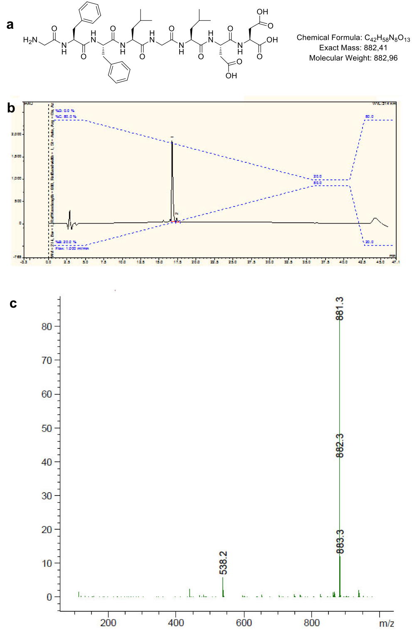

Figure S 1. Peptide synthesis and characterization of 2a. (a) chemical structure of 2a with mass analysis. (b) 2a peptide sequence was analyzed by HPLC (20-80% Solvent B) and shows a retention time of 16.8 min. (c) LCMS results are as follows: LC (5-100% Solvent D, retention time =10.1 min) and MS (mass calculated: [M-H]-= 881.4, mass observed: [M-H]- = 881.3).

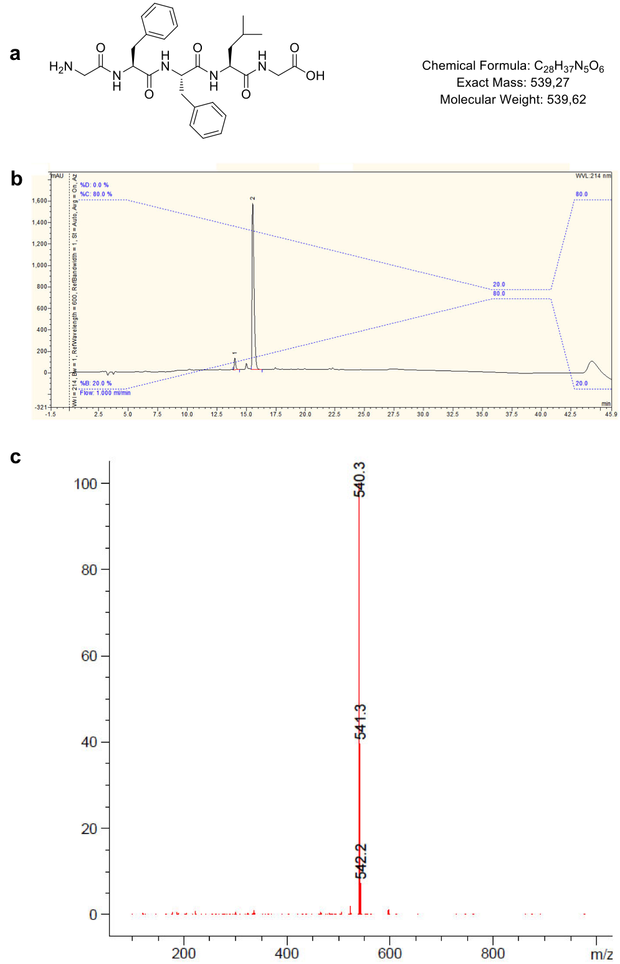

Figure S 2. Peptide synthesis and characterization of 2b. (a) chemical structure of 2b with mass analysis. (b) 2b peptide sequence was analyzed by HPLC (20-80% Solvent B) and shows a retention time of 15.6 min. (c) LCMS results are as follows: LC (5-100% Solvent D, retention time = 10.1 min) and MS (mass calculated: [M+H]+= 540.3, mass observed: [M+H]+ = 540.3).

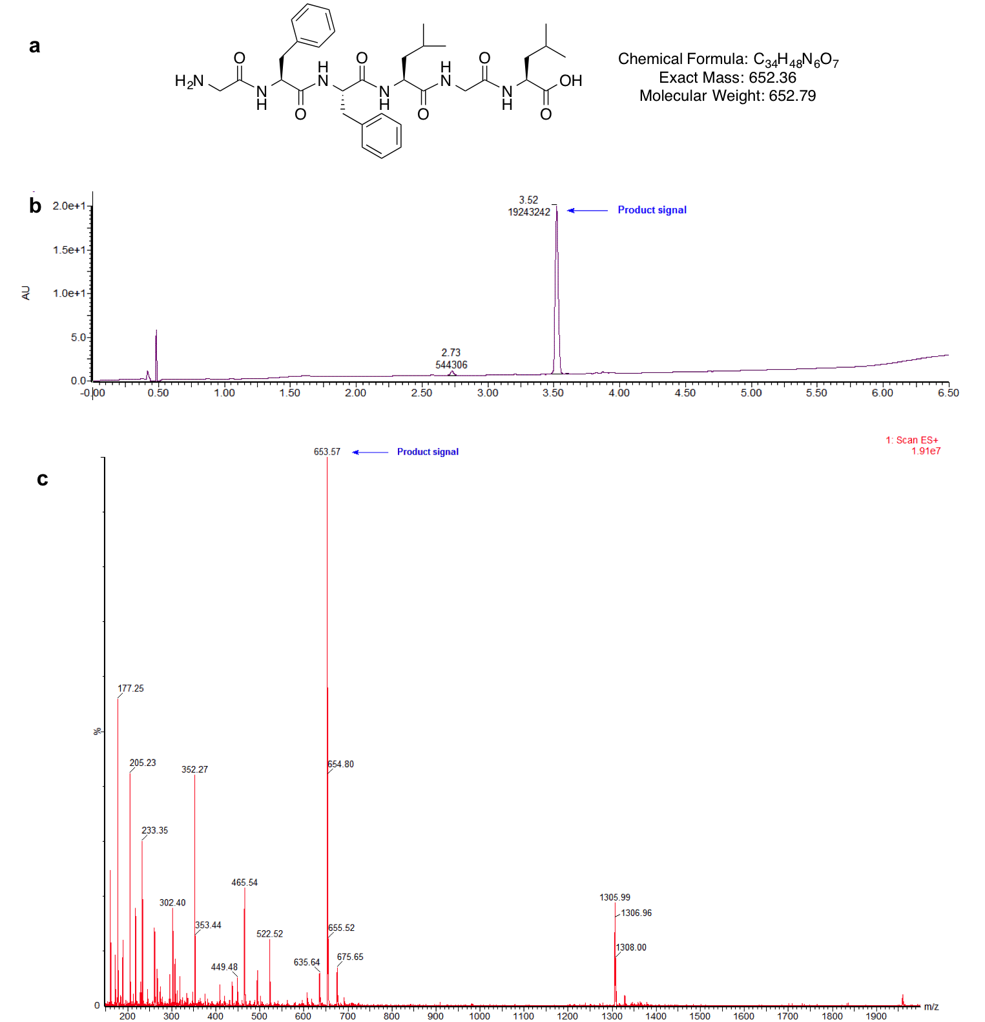

Figure S 3. Peptide synthesis and characterization of 2c. (a) chemical structure of 2c with mass analysis. (b) UPLC (data provided by CEM) results are as follows: retention time = 3.5 min and (c) MS (mass calculated: [M+H]+= 653.3, mass observed: [M+H]+ = 653.5).

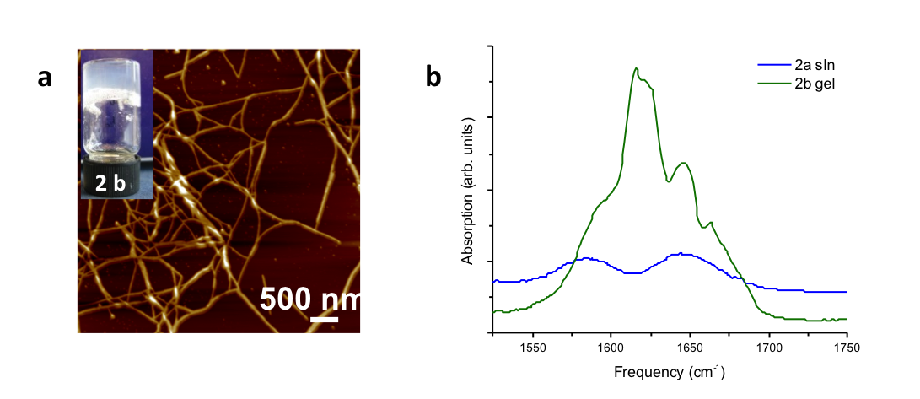

Figure S 4. Self-assembly characterization of 2b. (a) Atomic force microscopy (AFM) showing fibres (hydrogels – 20 mM) for 2b. (b) FTIR absorption spectrum in the amide I region (in D2O at pH 7): 2a (solution) and 2b (gel).

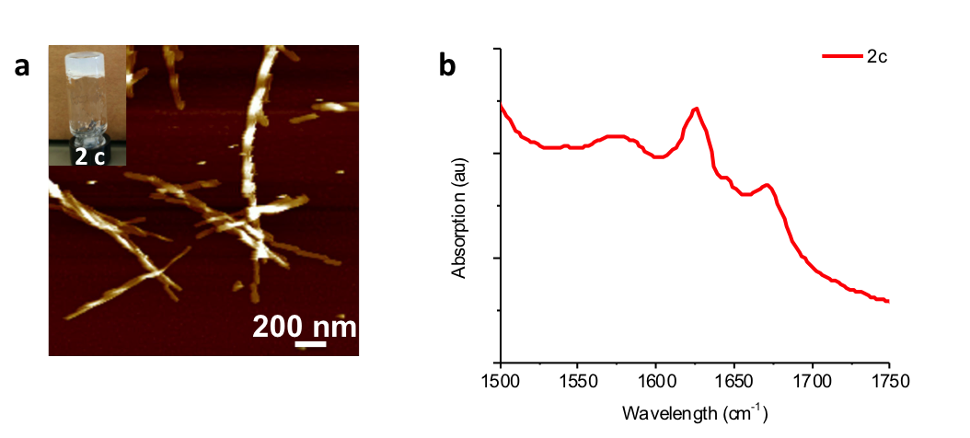

Figure S 5. Self-assembly characterization of 2c. (a) AFM showing fibres for hydrogels (20 mM) for 2c. (b) FTIR absorption spectrum in the amide I region (D2O, pH 7) for 2c gel.

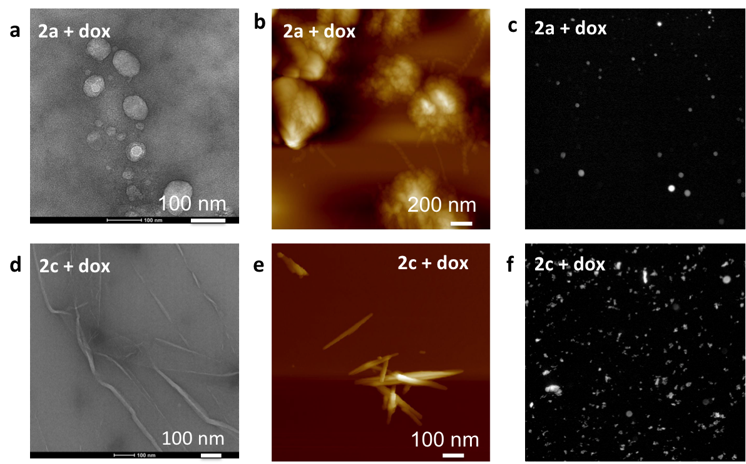

Figure S 6. Self-assembly characterization in presence of doxorubicin. (a) TEM, (b) AFM and (c) fluorescence microscopy (magnification 10x) images of doxorubicin loaded octapeptide (2a) showing that micelle formation was not disrupted by the presence of the drug (doxorubicin) and that the doxorubicin (fluorescence microscopy) is retained in the micelles. (d) TEM and (e) AFM showing the synthetically made observed cleavage product (2c) confirming fibers are forming in presence of doxorubicin and (f) fluorescence microscopy (magnification 10x) showing doxorubicin entrapment in the fibers.

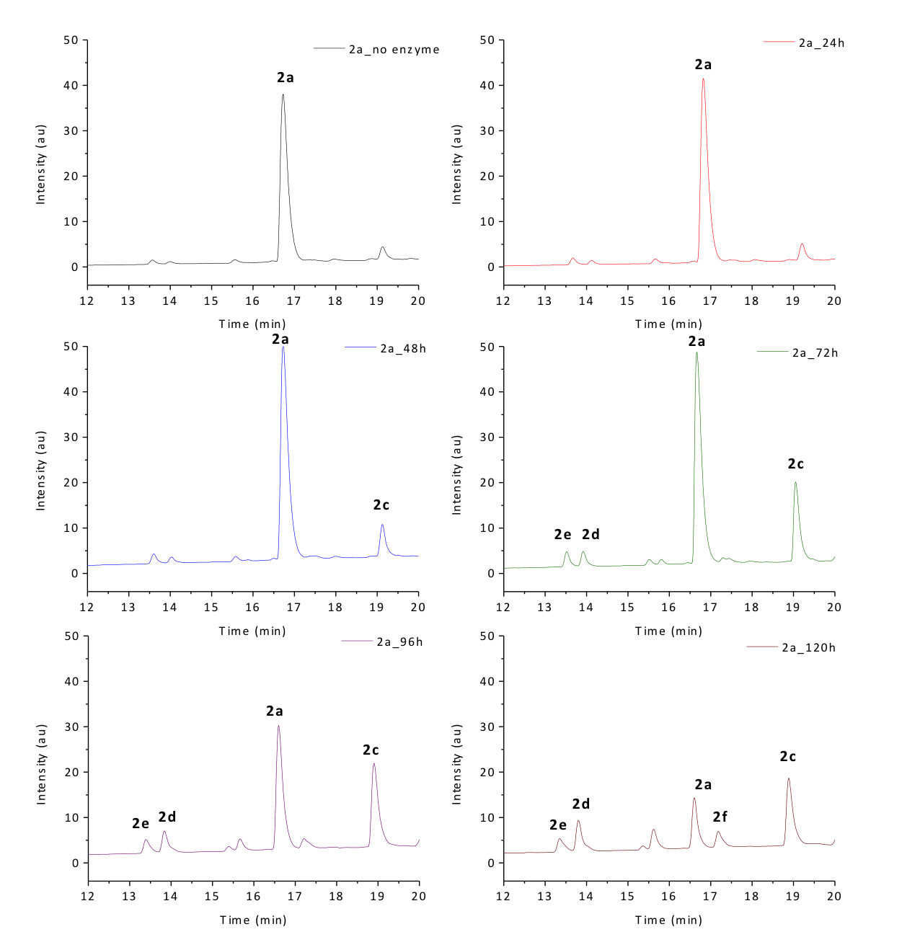

Figure S 7. HPLC of peptide (2a) digestion with MMP-9. HPLC chromatograms showing the MMP-9 induced digestion of 2a monitored over 120 h. Product formation at different time points is showed: time 0 (no enzyme), 24 h, 48 h. 72 h, 96 h and 120 h. More in detail, GFFLGLDD is converted to 3 main products after 96 h: GFFLGL (2c): HPLC (20-80% Solvent B, retention time = 18.9 min). LCMS: LC (5-100% Solvent D, retention time = 10.3 min), MS (mass calculated: [M-H]-= 651.3, mass observed: [M-H]- = 651.3); GFF (2d): HPLC (20-80% Solvent B, retention time = 14.1 min). LCMS: LC (5-100% Solvent D, retention time = 8.6 min), MS (mass calculated: [M-H]-= 368.1, mass observed: [M-H]- = 368.1); FLGLDD (2e): HPLC (20-80% Solvent B, retention time = 13.7 min). LCMS: LC (5-100% Solvent D, retention time = 8.5 min), MS (mass calculated: [M+H]+= 679.3, mass observed: [M+H]+ = 679.3). After 120 h further fragmentation of the substrate is observed, but also the digestion of the GFFLGL product (2c) into GF and FLGL (2f): HPLC (20-80% Solvent B, retention time = 17.2 min). LCMS: LC (5-100% Solvent D, retention time = 9.3 min), MS (mass calculated: [M-H]- = 447.2, mass observed: [M-H]- = 447.1)

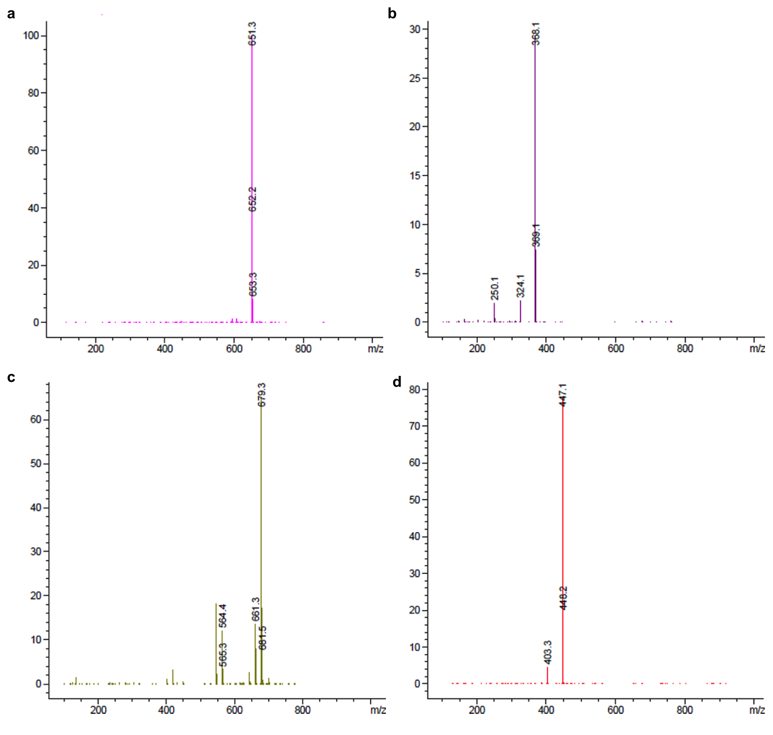

Figure S 8. Mass spectra of peptide (2a) digestion with MMP-9. MS data for (a) GFFLGL (2c), (b) GFF (2d), (c) FLGLDD (2e) and (d) FLGL (2f) described in the previous figure (Supplementary Figure 7).

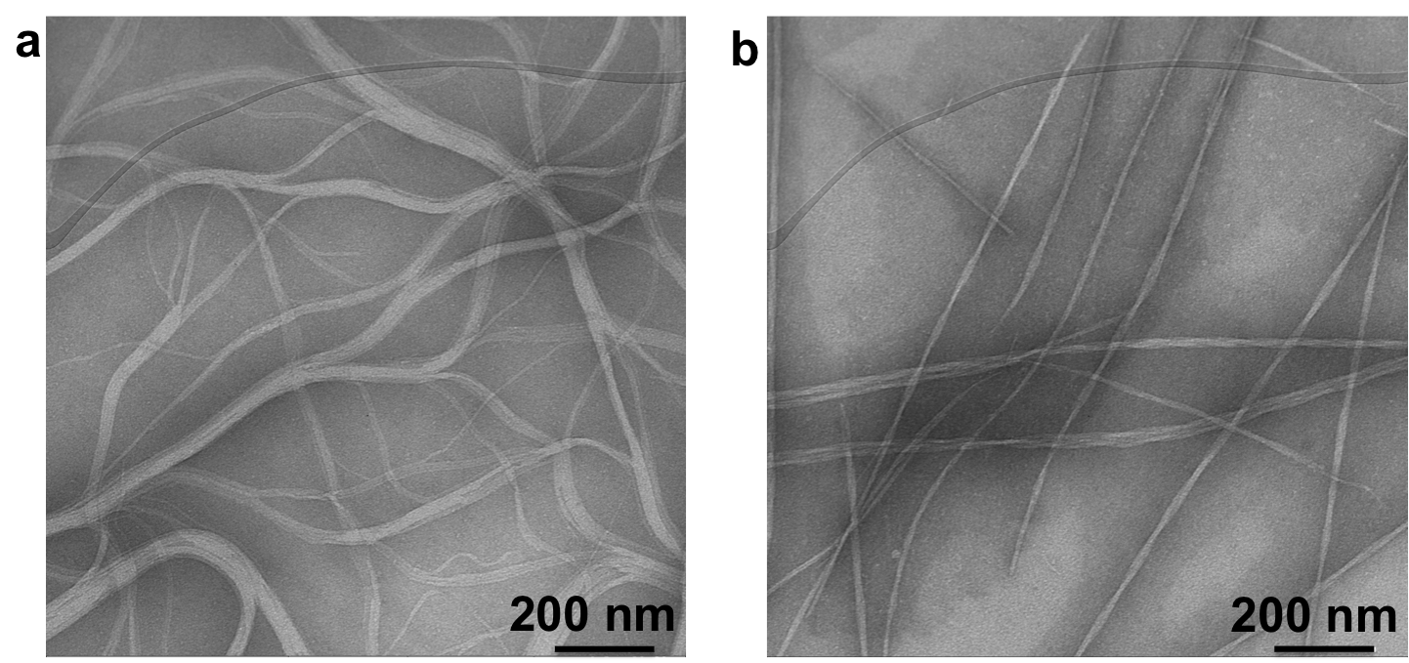

Figure S 9. TEM images. (a) 1a and (b) 2a treated with MMP-9 for 96 h to form fibers of 1c and 2c, respectively.

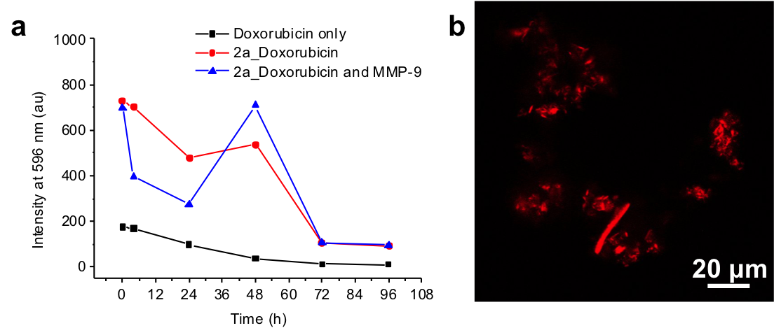

Figure S 10. Doxorubicin fluorescence. (a) Fluorescence intensities of doxorubicin monitored over time for doxorubicin only, doxorubicin loaded into precursor peptide (2a) micelles and MMP-9 treated precursor peptide (2a) micelles loaded with doxorubicin. (b) Confocal microscopy after MMP-9 treatment confirming that the doxorubicin is trapped in the peptide fibers.

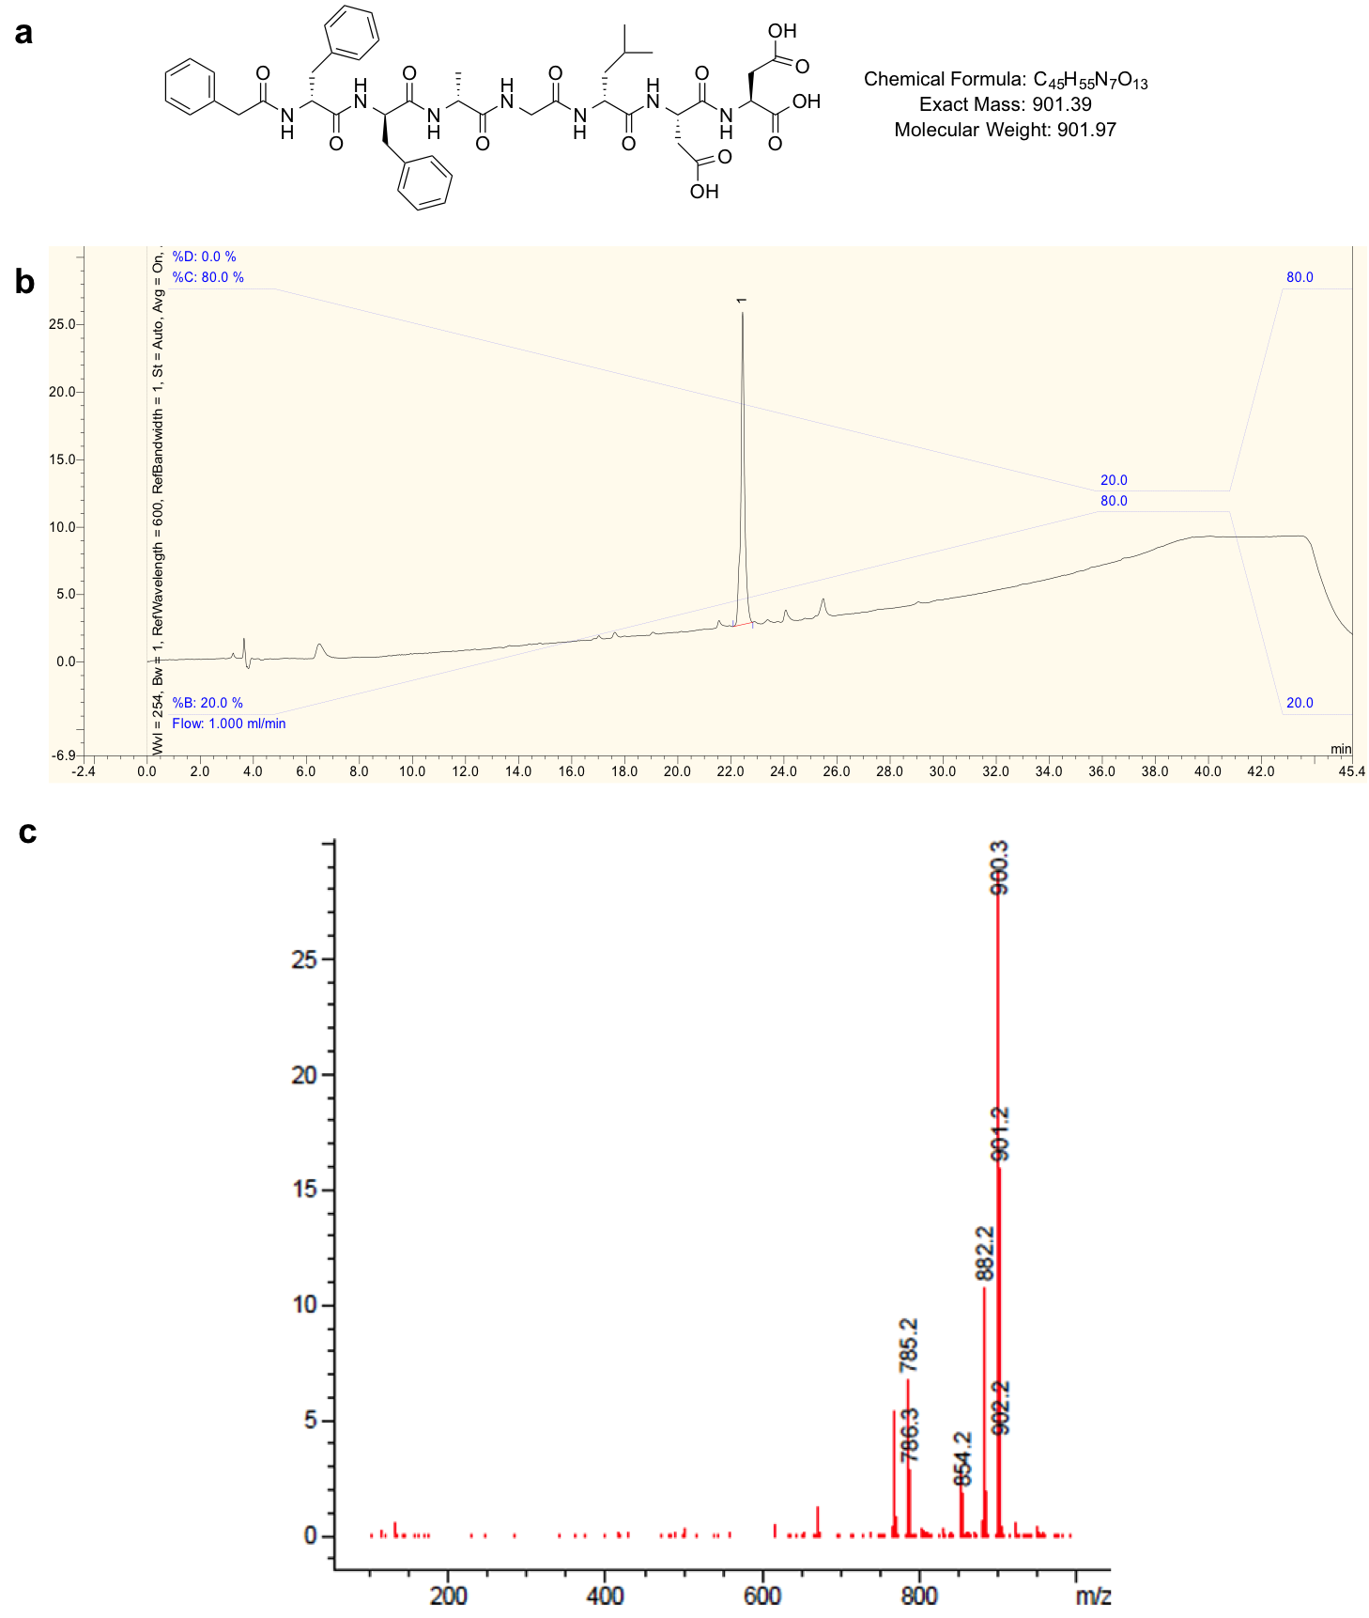

Figure S 11. Peptide synthesis and characterization of 1a(D). (a) chemical structure of 1a(D) with mass analysis. (b) 1a(D) peptide sequence was analyzed by HPLC (20-80% Solvent B) and shows a retention time of 22.5 min. (c) MS (mass calculated: [M-H]-= 900.4, mass observed: [M-H]- = 900.3).

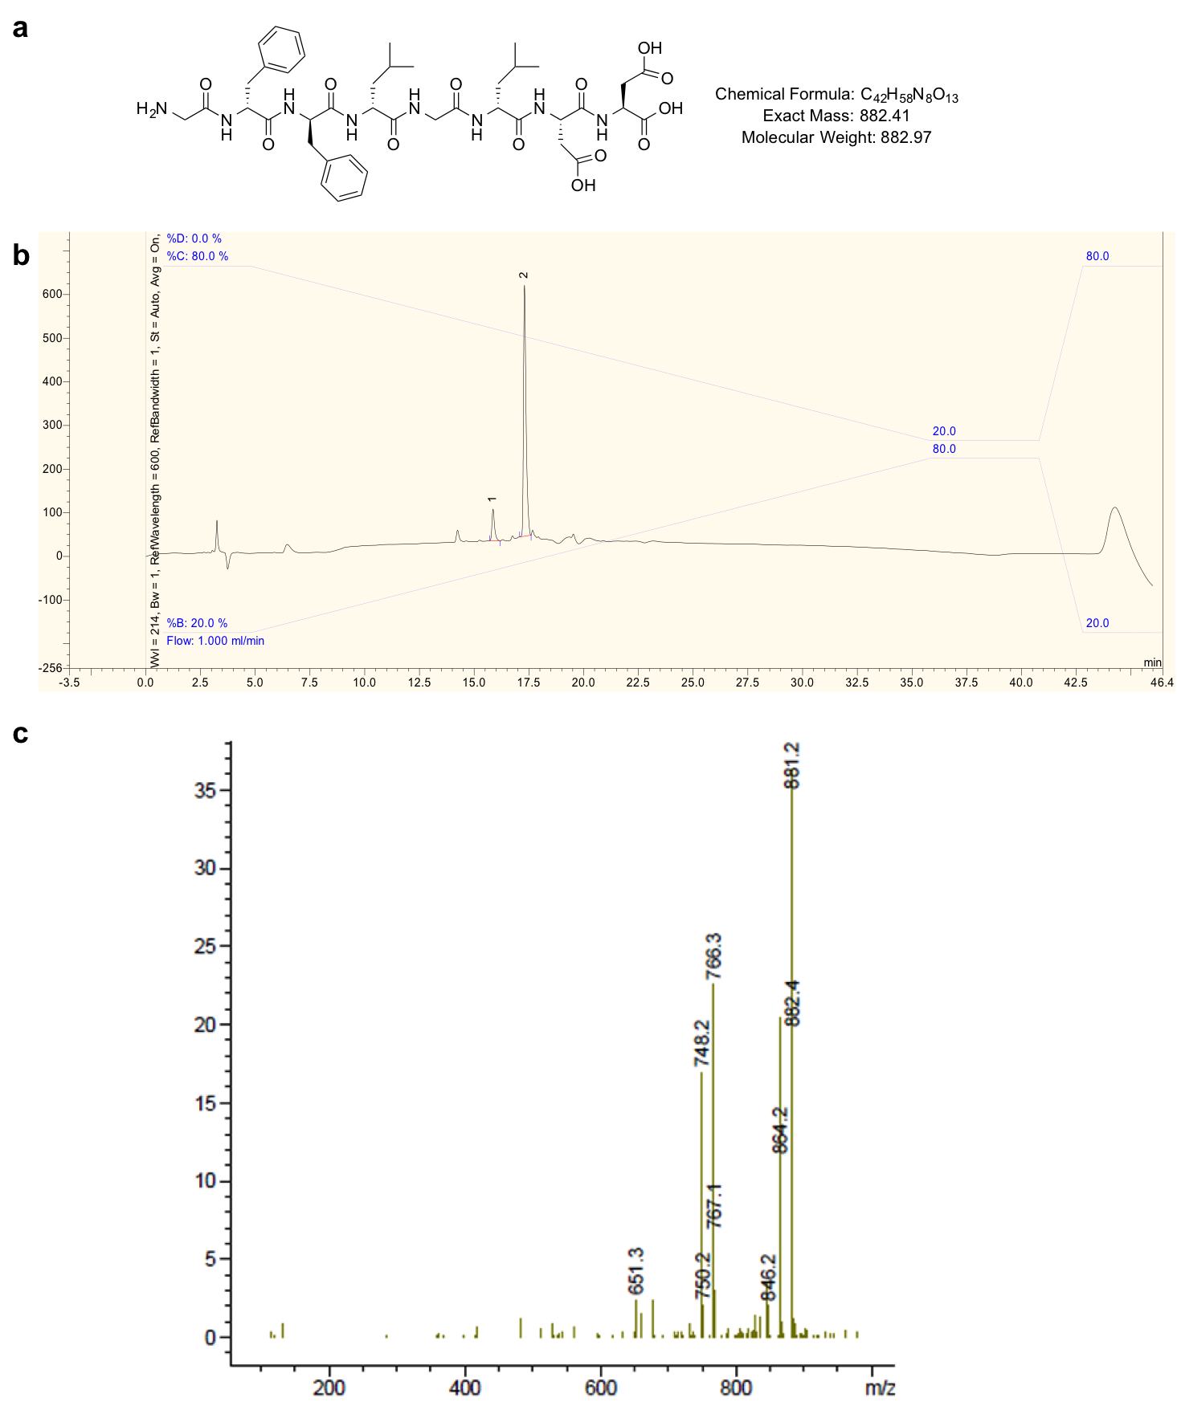

Figure S 12. Peptide synthesis and characterization of 2a(D). (a) chemical structure of 2a(D) with mass analysis. (b) 2a(D) peptide sequence was analyzed by HPLC (20-80% Solvent B) and shows a retention time of 17.5 min. (c) MS (mass calculated: [M-H]-= 881.4, mass observed: [M-H]- = 881.2).

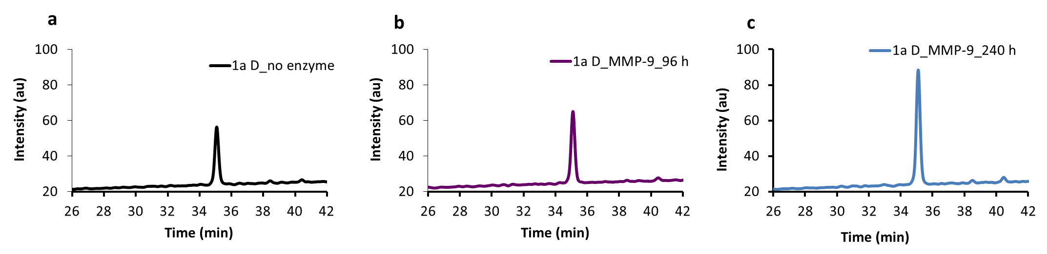

Figure S 13. HPLC of peptide 1a D treated with MMP-9 for 10 days to assess stability*.* HPLC chromatograms showing the resistance of 1a D to MMP-9 digestion monitored at (a) time 0 (no enzyme), (b) 96 h and (c) 240 h. 1a (D) peptide sequence was analyzed by HPLC (30-50% Solvent B, 70 min) and shows a retention time of 35.1 min for all three time points.

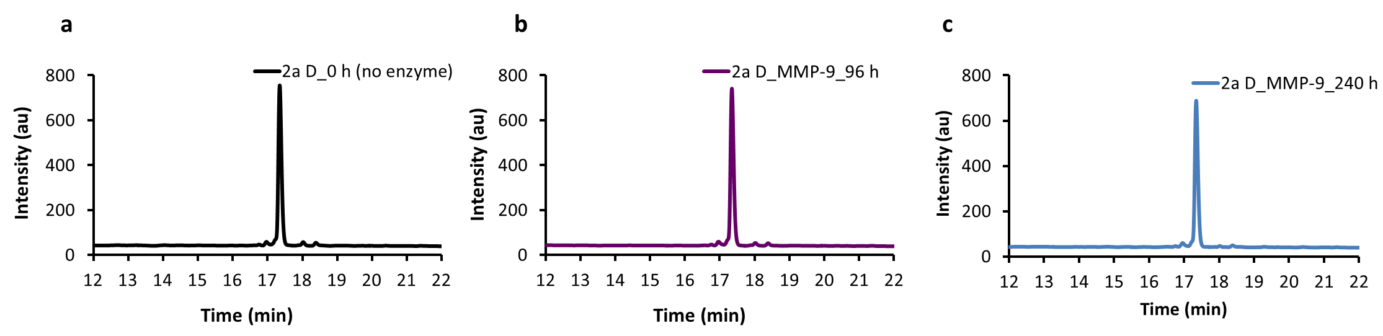

Figure S 14. HPLC of peptide 2a D treated with MMP-9 for 10 days to assess stability. HPLC chromatograms showing the resistance of 2a D to MMP-9 digestion monitored at (a) time 0 (no enzyme), (b) 96 h and (c) 240 h. 2a (D) peptide sequence was analyzed by HPLC (20-80% Solvent B, 45 min) and shows a retention time of 17.5 min for all three time points.

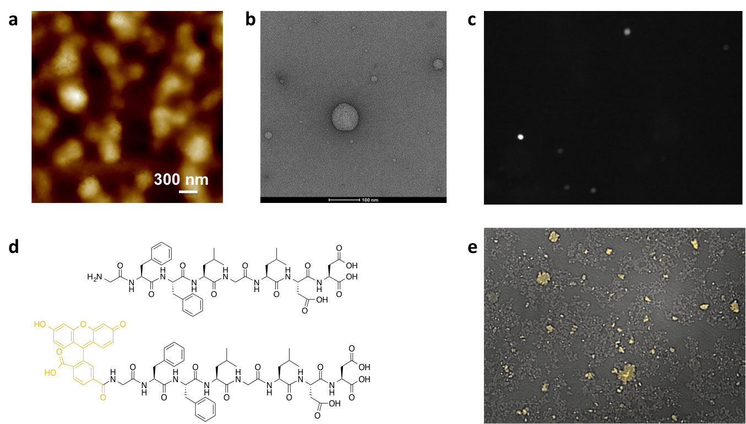

Figure S 15. Co-assembly of 2a with 1% of carboxyfluorescein-2a for visualization. In order to visualize the peptide distribution in presence of cells, the co-assembly of 2a with 1% of carboxyfluorescein-2a was studied and characterized by AFM, TEM and fluorescence microscopy. (a) AFM, (b) TEM (scale bar: 100 nm), (c) and (e) fluorescence microscopy (magnification 10x) of the co-assembled structures formed by mixing of 2a and carboxyfluorescein-2a. (d) Chemical structures of 2a and carboxyfluorescein-2a.

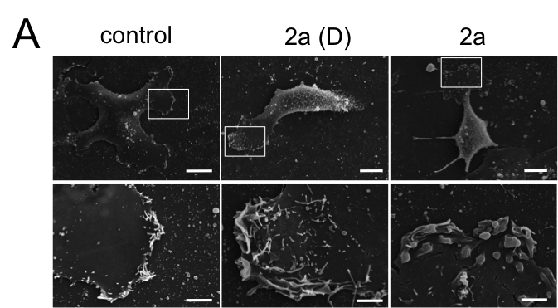

Figure S 16. Effect of the MMP-9 cleavable peptide 2a on cell morphology *in vitro*.​ Altered lamellipodia morphology upon PMA stimulation after 3 day treatment with 2.5 mM of peptide 2a (D) or 2a visualized by SEM; top panel, bar: 10 μm; lower panel magnified selected region, bar: 2 μm.

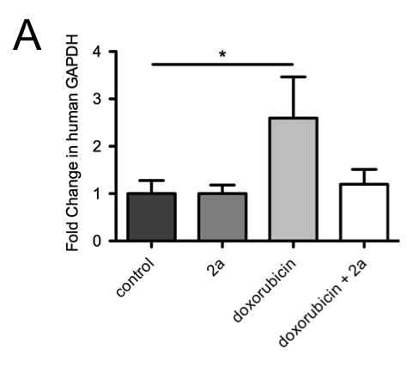

Figure S 17. MMP-9 cleavable peptide carrier 2a rescues effect of doxorubicin treatment on circulating tumor cells. ​A Quantification of circulating tumor cells in the blood of subcutaneous tumor bearing nude mice by RT-PCR, measuring human GAPDH levels normalized to murine beta-2-microglobulin; bars: mean of fold change. Error bars: SEM; n = 3-4 mice; * p < 0.05 by standard student’s *t*-test.

**Supplementary methods**

**High-performance liquid chromatography.** HPLC analyses of peptides were performed using Dionex P680 HPLC system equipped with a Macherey-Nagel C18 column of 250 mm length, 4.6 mm internal diameter and 5 mm particle size equipped with UV-Vis detector. The gradient: (Solvent A: 0.1% TFA in water; Solvent B: 0.1% TFA in acetonitrile) 20-80% B was utilized, with each run lasting a total of 46 minutes using a flow rate of 1 mL min-1 and detection wavelengths set at 214 nm and 254 nm using the UV-Vis detector. For separation of peptides **1a** and **1c** a 30-50% B gradient was utilized with each run lasting a total of 70 minutes using a flow rate of 1 mL min-1 and detection wavelengths set at 214 nm and 254 nm using the UV-Vis detector.

**Liquid chromatography-mass spectrometry.** LC-MS obtained at the University of Strathclyde Mass Spectrometry facility was used to confirm peptide molecular weights. All analyses were carried out on a reverse-phase 15 cm Kinetex C18, 150 x 4.6 mm, 5 micron column. The LC-MS instrument was an Agilent 1200 Series HPLC, coupled to an Agilent 6130 Dual source MS detector. The gradient: (Solvent C: 5 mM ammonium acetate in water; Solvent D: 5 mM ammonium acetate in acetonitrile) 0-3 min 5% D, 3-17 min 5-100% D, 17-27 min 100% D, 27-33 min 100-5% D, and 33-36 min 5% D was used in all analyses; the flow rate was set at 1 mL min-1 and detection wavelengths at 214 nm. Mass detection was set to analyse in Scan mode with electrospray ionisation (MM-ES+APCI). For all peptides examined both positive and negative ions were detected but only one (positive or negative ion) is shown for peptide characterisation to avoid redundancy.

**Fourier Transform Infrared Spectroscopy.** FTIR spectra were recorded on a Bruker Vertex 70 spectrometer. Samples were prepared in deuterated phosphate buffer (pH=8) and placed between two CaF2 cells with 12mm diameter polytetrafluoroethylene (PTFE) spacers. Absorbance spectra were taken from 4000cm-1 to 800cm-1 with 64 scans at 4cm-1 resolution.

**Fluorescent microscope** images were captured on the GE Cytell Imaging System using the Digital Imaging program. Samples were prepared on a standard glass slide and an 18x18mm micro cover glass was placed on top. Pictures were taken at 2000-2500 focus (micron).

**Doxorubicin encapsulation.** Doxorubicin hydrochloride was solubilized in DMSO by sonication and 1 mM stock solution was made in PBS was made and subsequently diluted into the suspension of peptide micelles (final concentration of doxorubicin: 5 μM). The samples were then sonicated to allow doxorubicin diffusion into the hydrophobic core of the micelles. Fluorescence intensity of doxorubicin at 596 nm that corresponds to the maximum intensity (λex = 480 nm) was monitored over 96 h when incorporated into the **2a** peptide system with and without addition of MMP-9. A control experiment with free doxorubicin (doxorubicin in water, no peptide present) shows a low fluorescence intensity as previously reported (more intense fluorescence signal of doxorubicin is observed in hydrophobic environment compared to water- as fluorescence intensity changes with the polarity of the environment).1,2

**Fluorescence** **emission spectra** were measured on a Jasco FP-6500 spectrofluorometer. Doxorubicin was excited at 480 nm and the emission intensity at 596 nm was monitored over time. The excitation and emission bandwidths were both set to 5 nm.

**CRISPR sequences.**

|  |  |  |
| --- | --- | --- |
| MMP-9 CRISPR-for | CACCGTGTACCGCTATGGTTACACT | primer for CRISPR of human MMP-9, Exon 1, 93% |
| MMP-9 CRISPR-rev | AAACAGTGTAACCATAGCGGTACAC | Primer for CRISPR of human MMP-9, Exon 1, 93% |

**Quantification of circulating tumor cells**. Circulating tumor cells were detected as described previously3,4, briefly 500 μL of blood was collected by cardiac puncture, snap frozen and kept at -70C. RNA was isolated using the Ambion Mouse RiboPureTM-Blood RNA Isolation Kit (AM1951, Applied Biosystems) and ~ 1 μg used for cDNA synthesis using SuperScriptTM kit (ThermoFisher Scientific, Life Technologies). Using qPCR SYBR®Green (ThermoFisher Scientific) the levels of human GAPDH were quantified after normalization to murine beta-2-microglobulin, using the comparative C(t) value method5.

(1) Hughes, M.; Birchall, L. S.; Zuberi, K.; Aitken, L. a.; Debnath, S.; Javid, N.; Ulijn, R. V. Differential Supramolecular Organisation of Fmoc-Dipeptides with Hydrophilic Terminal Amino Acid Residues by Biocatalytic Self-Assembly. *Soft Matter* **2012**, *8*, 11565.

(2) Kalafatovic, D.; Nobis, M.; Javid, N.; Frederix, P. W. J. M.; Anderson, K. I.; Saunders, B. R.; Ulijn, R. V. MMP-9 Triggered Micelle-to-Fibre Transitions for Slow Release of Doxorubicin. *Biomater. Sci.* **2015**, *3*, 246–249.

(3) Padua, D.; Zhang, X. H.-F.; Wang, Q.; Nadal, C.; Gerald, W. L.; Gomis, R. R.; Massagué, J. TGFbeta Primes Breast Tumors for Lung Metastasis Seeding through Angiopoietin-like 4. *Cell* **2008**, *133*, 66–77.

(4) Gupta, G. P.; Nguyen, D. X.; Chiang, A. C.; Bos, P. D.; Kim, J. Y.; Nadal, C.; Gomis, R. R.; Manova-Todorova, K.; Massagué, J. Mediators of Vascular Remodelling Co-Opted for Sequential Steps in Lung Metastasis. *Nature* **2007**, *446*, 765–770.

(5) Schmittgen, T. D.; Livak, K. J. Analyzing Real-Time PCR Data by the Comparative CT Method. *Nat. Protoc.* **2008**, *3*, 1101–1108.